CODIC 2021 on Zoom. May v 2/24/2021 7:58 PM

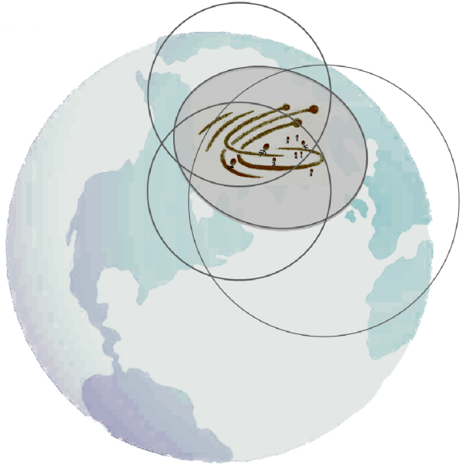

Expanding Your Power, v3

Your Catalytic Leadership on a Larger Scale
COVID, Anti-Racism and Zoom have opened a door
on a scale never seen. What can you change now?
- Is this our once-in-a-lifetime chance to change our organizations and our corners of the world?
- If this is our big opportunity, what powerful allies might you engage?
Change involves "Power," and power has been abused, feared, misunderstood—
and mainly, unchallenged. What if we can now build power on a larger scale?
And if we don't now focus and use new power, will our organizations lock into a "new normal" for decades more of polarization and dysfunction?
Without power for effective, human change, we'll be stuck with whatever is sold to the masses by leaders whose goal is to gain the most for themselves.
How can we significantly expand our power now, while the door is open?
In this program, we will explore and experiment together. A Power Lab helps consultants and clients focus and use the power that shapes the "new ways" in each organization. We've used Power Labs and the Strategic Action System in crisis and strategic planning with dozens of global corporations, government and non-profit organizations that had to change suddenly.
But this Power Lab is a short, online experiment. The idea is to spark your own experiments.
Where can your own power
"get real" on a greater scale now?
- Your Business Role?
… What if caring gets embedded?
- A project you are in?
… Can it have much broader leverage?
- Medicine, Schools or Politics?
…Can you be a community catalyst?

For 3 weeks after the program, you may also want to test and focus your own power—with a supporting partner from the CODIC program.
We will hold a Power Huddle in three weeks, to share what we each tested, learned, achieved and want to try next.
——— ——— ———

Community of OD in Chicago. May, 2021 Program
Expanding Your Power, v3.
Mission: To infuse greater power, ethically and deeply, into your work of the next few months.
Objectives.
- To expand your own power to shape the networks— that will now shape your organizations.
- To create antidotes to damaging, dominating power forms—by fostering agile collaboration.
- To bring your peers and clients a safe, simple tools to expand their understanding of power.
- To make a difference now. Maybe with CODIC, maybe with your own work project.

